Name: Mujtaba Ali Naqvi

Stream: XII- PCM

“Wetlands: Mankind’s Waterlogged Wealth”
Necessity and perspective of Wetland Management in India

“Wetland conservation ensures drinking water and food security”

W h a t i s a W e t l a n d ??

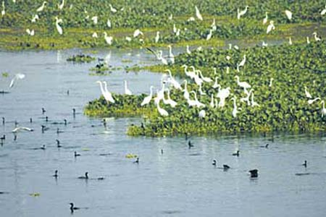

A wetland is an area of ground that is saturated with water either permanently or seasonally. Wetlands are categorized by their characteristic vegetation, which is adapted to these unique soil conditions. The water found in wetlands can be saltwater, freshwater, or brackish. Wetlands include swamps, marshes, and bogs.
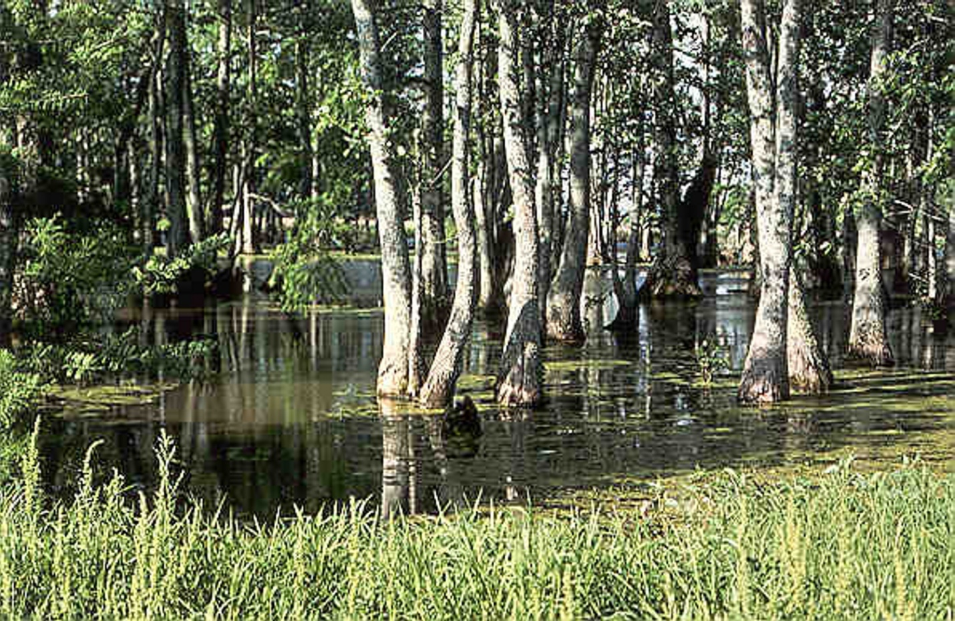

Wetlands are found on every continent except Antarctica. Wetlands may be converted for agriculture or development or constructed as a water management tool. Wetlands also are known internationally as inland water or coastal / marine ecosystems.

Under Ramsar International Wetland conservation treaty, an international agreement signed by 160 countries, wetlands are defined as follows:
- Article 1.1 : "... wetlands are areas of marsh, fen, peatland or water, whether natural or artificial, permanent or temporary, with water that is static or flowing, fresh, brackish or salt, including areas of marine water the depth of which at low tide does not exceed six metres."

Wetlands Classification Scheme:
Inland Wetlands
1. Natural | - Lakes / Ponds  - Ox-bow lakes/ Cut-off meanders  - Waterlogged (Seasonal)  - Playas  - Swamp / marsh
2. Man-made | - Reservoirs  - Tanks  - Waterlogged  - Abandoned quarries  - Ash pond/ cooling pond
Coastal Wetlands
1. Natural | - Estuary  - Lagoon  - Creek  - Backwater (Kayal)  - Bay  - Tidal flat/ Split/ Bar  - Coral reef  - Rocky coast  - Mangroove forest  - Salt marsh/marsh vegetation  - Other vegetation
2. Man-made | - Salt pans  - Aquaculture

T h r e a t s t o t h e W e t l a n d s :

- The ever increasing human population in India has been the root cause for the depletion of wetlands. Wetlands are being pushed to their limits to provide enough space for human beings. The pressure of human encroachment have rendered Wetlands helpless.

- Pollution has also played a significant role in the depletion of Wetlands. Uncontrolled drainage of human and toxic waste into the water bodies have caused a great damage to these water bodies.

- Mining and over grazing, too, have slowly but gradually destroyed the wetlands of India.

- Unsustainable water use have also inflicted serious damage to the wetlands.

N e e d T o C o n s e r v e W e t l a n d s :

For ages, human have exploited the wetlands to fulfill their own greedy and selfish motives. However, this over – exploitation have critically declined the condition of these wetlands. This has lead to extinction of many species of animals and also damaged the aquatic flora and fauna. Pollution of these wetlands have lead to many chronic diseases like cholera, typhoid etc.

But we have to put a stop to this !

- Wetlands are vital ecosystems that provide livelihoods for the millions of people who live in and around them.

- Wetlands are integral to a healthy environment. They help to retain water during dry periods, thus keeping the water table high and relatively stable.

- During periods of flooding, they act to reduce flood levels and to trap suspended solids and nutrients to the lakes than if they flow directly into the lakes. The removal of such wetland systems because of urbanization or other factors typically causes lake water quality to worsen.

- In addition, wetlands are important feeding, breeding, and drinking areas for wildlife and provide a stopping place and refuge for waterfowl.

- As with any natural habitat, wetlands are important in supporting species diversity and have a complex and important food web.

W e t l a n d M a n a g e m e n t :

The wetland management program generally involves activities to protect, restore, manipulate, and provide for the functions and values emphasizing both quality and acreage by still advocating sustainable usage of them . Management of wetland ecosystems requires an intense monitoring, increased interaction and co-operation among the various government and non government agencies. Such management goals should not only involve buffering wetlands from any direct human pressures that could affect the wetlands’ normal functions, but also in maintaining important natural processes that operate on them that may be altered by human activities.

How i t c a n b e d o n e ??

- The management strategies should involve protection of wetlands by regulating inputs using water quality standards promulgated for wetlands and such inland surface waters to promote their normal functioning from the ecosystem perspective, still deriving economic benefits by sustainable usage.

- Poachers, fishermen and all those altering the balance of wetlands should be put under constant scrutiny so that they think twice before inflicting any serious damage to water bodies.

- Pollution, overgrazing and mining should be checked regularly.

- Large scale plantation of trees would be beneficial as it reduces soil erosion, pollution etc.

- Land use should be checked.

C o n c l u s i o n s :

Wetlands are crucial for the survival of human beings on earth. Wetlands provide livelihoods to many people and also provides a life support system for flora and fauna. Wetlands also play an indispensable role in the development of a country. Any damage to wetlands would greatly affect our future generations.
Therefore, one cannot risk such a precious ecosystem. There is an immediate need of conserving wetlands and every citizen has his role to play in this.
Come friends! Lets create a greener, healthier and peaceful world . Lets start by conserving wetlands for Alfred Lord Tennyson said in his beautiful poem The Brook –

“…for men may come and men may go, but I go on forever…”

